Congo, Rep.

## Freedom House political status

The data set shows the Freedom House political scores and status of the country each year.

## # A tibble: 19 x 5  
## country iso3c date mean status   
## <chr> <chr> <dbl> <dbl> <chr>   
## 1 Congo, Rep. COG 1996 4 Partly Free  
## 2 Congo, Rep. COG 1998 6 Not Free   
## 3 Congo, Rep. COG 2000 5 Partly Free  
## 4 Congo, Rep. COG 2002 5 Partly Free  
## 5 Congo, Rep. COG 2003 4.5 Partly Free  
## 6 Congo, Rep. COG 2004 4.5 Partly Free  
## 7 Congo, Rep. COG 2005 5 Partly Free  
## 8 Congo, Rep. COG 2006 5.5 Not Free   
## 9 Congo, Rep. COG 2007 5.5 Not Free   
## 10 Congo, Rep. COG 2008 5.5 Not Free   
## 11 Congo, Rep. COG 2009 5.5 Not Free   
## 12 Congo, Rep. COG 2010 5.5 Not Free   
## 13 Congo, Rep. COG 2011 5.5 Not Free   
## 14 Congo, Rep. COG 2012 5.5 Not Free   
## 15 Congo, Rep. COG 2013 5.5 Not Free   
## 16 Congo, Rep. COG 2014 5.5 Not Free   
## 17 Congo, Rep. COG 2015 5.5 Not Free   
## 18 Congo, Rep. COG 2016 6 Not Free   
## 19 Congo, Rep. COG 2017 6 Not Free

## Freedom House classification of political change

The data set shows the GDP growth and the ecomic growth classification of the country each year.

## # A tibble: 19 x 4  
## country iso3c date politicalChangeFH  
## <chr> <chr> <dbl> <chr>   
## 1 Congo, Rep. COG 1996 no change   
## 2 Congo, Rep. COG 1998 no change   
## 3 Congo, Rep. COG 2000 democratization   
## 4 Congo, Rep. COG 2002 autocratization   
## 5 Congo, Rep. COG 2003 democratization   
## 6 Congo, Rep. COG 2004 no change   
## 7 Congo, Rep. COG 2005 autocratization   
## 8 Congo, Rep. COG 2006 autocratization   
## 9 Congo, Rep. COG 2007 no change   
## 10 Congo, Rep. COG 2008 no change   
## 11 Congo, Rep. COG 2009 no change   
## 12 Congo, Rep. COG 2010 no change   
## 13 Congo, Rep. COG 2011 no change   
## 14 Congo, Rep. COG 2012 no change   
## 15 Congo, Rep. COG 2013 no change   
## 16 Congo, Rep. COG 2014 no change   
## 17 Congo, Rep. COG 2015 no change   
## 18 Congo, Rep. COG 2016 autocratization   
## 19 Congo, Rep. COG 2017 no change

## Freedom House score trend

The plot shows the Freedom House scores trend of the country.

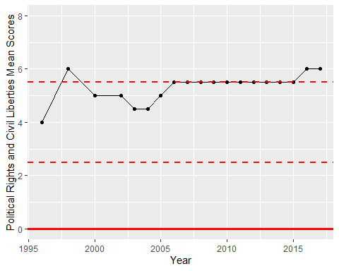

Freedom House Score Trend